The Play

The Players (or teams of two players, one at each end) take turns sliding pucks to score points. Flip a coin to decide who plays Red and who plays Blue; Red starts the first two rounds and then Blue takes the next two rounds and so on. Each round consists of sliding 4 pucks each, alternately. Each puck must be slid prior to the 10 point triangle. If a puck does not reach the furthest “dead line” (see diagram below), it is immediately removed from play. Touching the “dead line” stays in play.

Players aim is to push their own pucks into the scoring areas or strategically advantageous positions while also attempting to knock opponent’s pucks out of play or into the 10-off area.

Scoring

Scoring occurs once all eight pucks have been played to complete a round.
- Only puck(s) completely in the scoring area (7, 8, 10, & 10-off) are scored.
- Any puck touching any line in the scoring area or outside edge of the scoring area is not scored.
- 10 points deducted for any pucks in the 10-off area.
- Points are 7, 8, 10 or -10 (10-off).

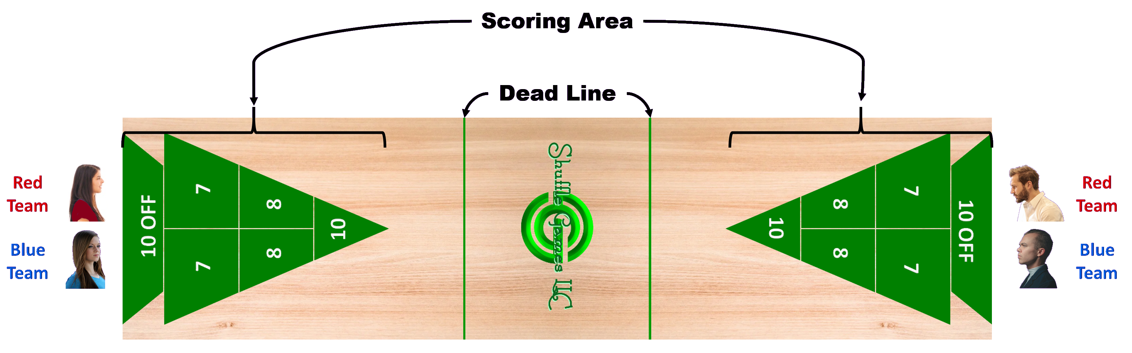The game is won by the first person to reach 75 points although this cannot be achieved during a game - all eight pucks of the final game must be played and the scores calculated before a player can claim victory.
See other side for Shuffle Golf Rules

