Curling
Mini Curling provides you with the chance to play curling without the brooms and o- the ice!
Each team begins with a total of 4 pucks/stones (stones are the blue and red rolling game pieces that travel on the board). The aim is to have more stones closer to the button (the yellow circle) than your opponent after each round when all 8 stones have been thrown.
2-Players
- Players will slide 4 stones each, alternatingly.
- Both players shoot from the same side.
4-Players
- Players will slide 4 stones each, alternatingly.
- Opposing team members will shoot side by side at both ends of the board (see diagram below).
- Players on each side will alternate rounds, clearing the board of all stones before a new round is commenced at the other side.

How to Play
- Determine who goes first by coin flip or any other method you prefer. Sometimes, having the last slide (the “hammer”) is advantageous.
- Players then alternate sliding stones, aiming for the button (yellow circle) so they come to rest past the farthest hog line - the area of the board with the black line near the logo (see diagram below).
- When sliding the stone to the opposite side of the board, your hand must not pass the first hog line (the line closest to the side you are shooting from).
- Every stone which falls into the gutter or doesn’t pass the farthest hog line, (the second hog line furthest from you) are removed from play.

Scoring
The team which manages to place a stone closest to the button (the yellow target) wins the round. The winning team gets one point for every stone closer to the button than the other team’s closest stone.
- Only stones within or overlapping the house (set of 4 circles) are scored. If a stone is touching the outer blue ring of the house this can still be counted as a point.
- It is also possible for no one to score points during a round if neither team gets any stones in the house.
- 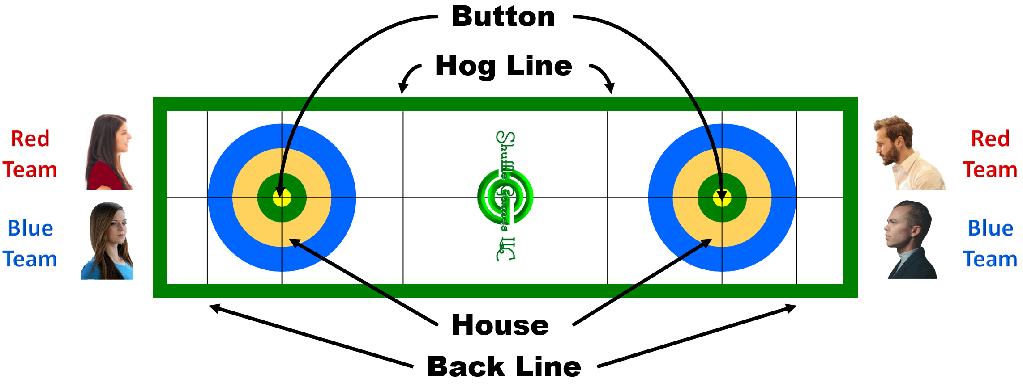The game ends when the first team gets to a total of 21 points.

